1st Grade Connection
May 11-15, 2026
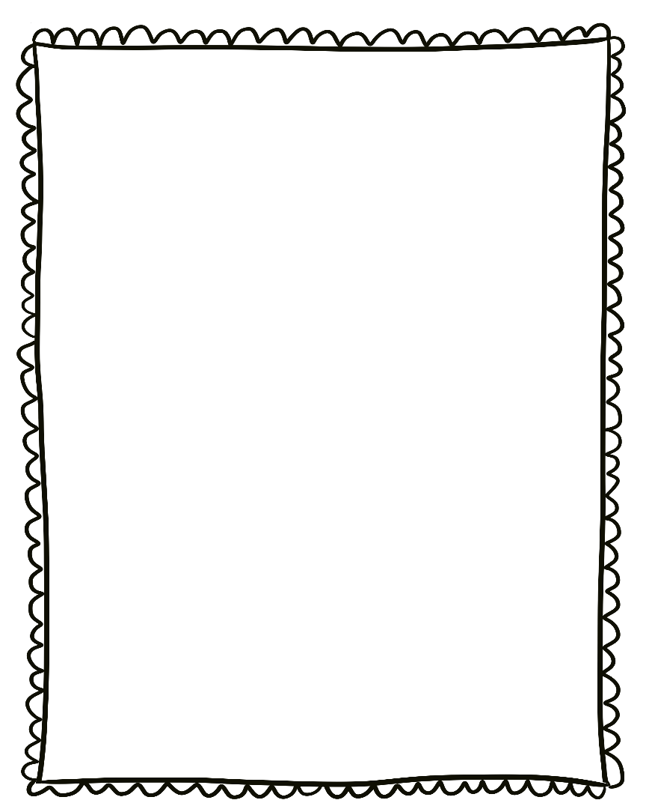
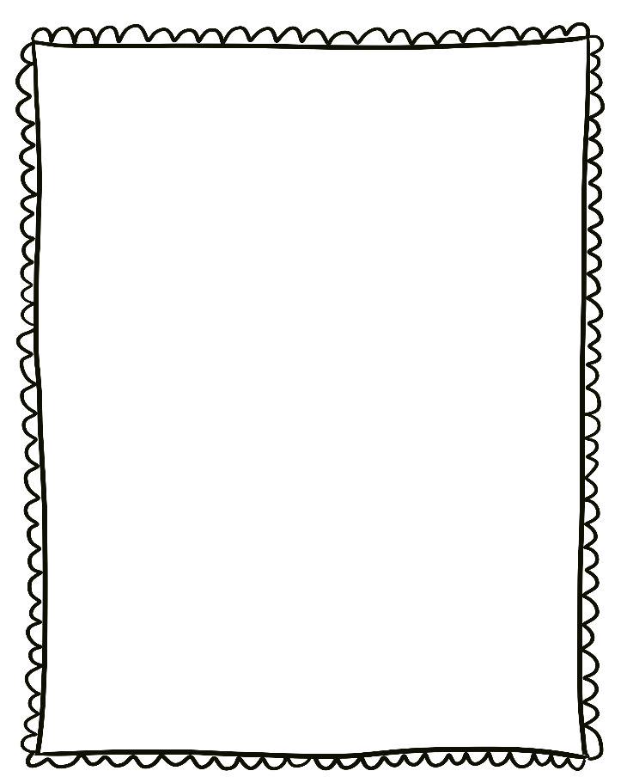
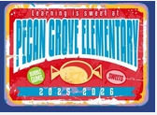
- Monday, May 11th: Paint the School Pink-wear pink
- Wednesday, May 13^{h}: College Wear Wednesday
- Wednesday, May 13th: End of Year MAP Growth Math
- Thursday, May 14th: Multi-Cultural Paade 8:30am
- Friday, May 15th: Field Day

Reminders:

- Please send a nutritious snack that is easy to eat to school with your student. All snacks must be peanut free. Examples of this include Cheez-Its, Pretzels, or baby.
carrots.

- Wear tennis shoes on PE days!

- Reading: Research

- Phonics: Inflectional Endings -s, es

- Writing: Research

- Conventions: Review

- Math: Time

- Social Studies: Year in Review

- Science: Animal Life Cycles

Upcoming Events/Grades
What we are learning:

